Launching an EC2 Instance (AWS)
- Go to search bar and Type EC2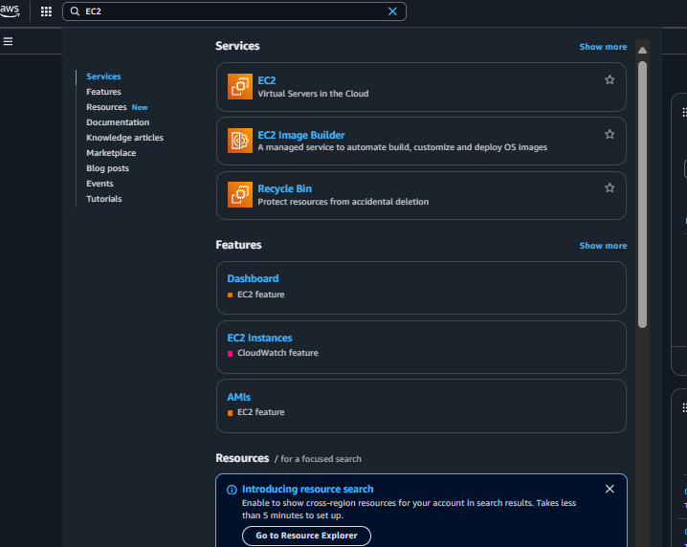
- Select EC2 virtual servers in the cloud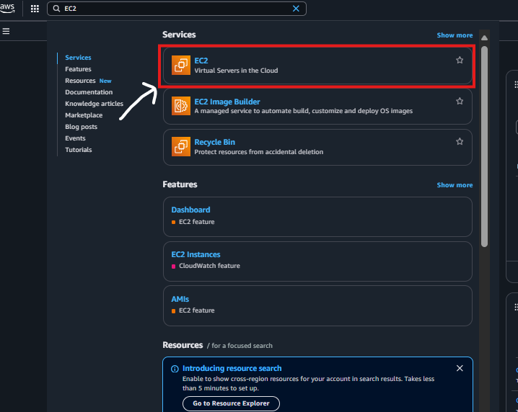
- Under network and security, select security groups in the left pane of the screen> create a security group allowing HTTP access on port 80 and SSH access on Port 22.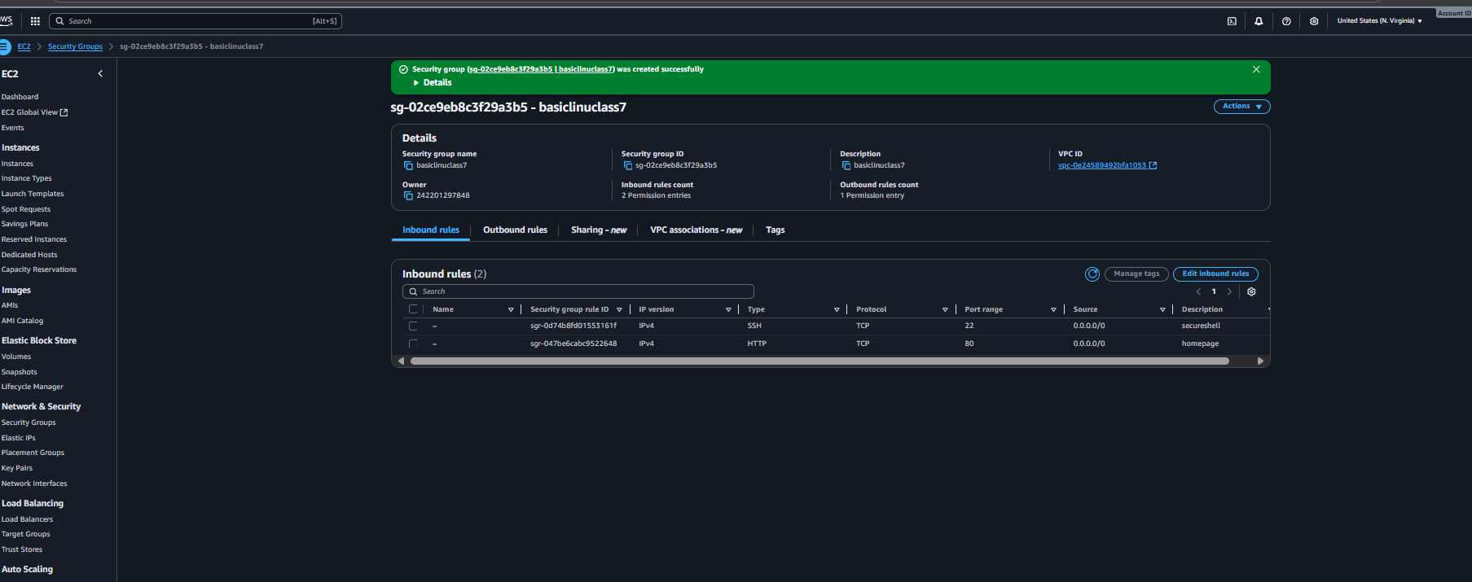
- After creating security group select instances in left pane of screen.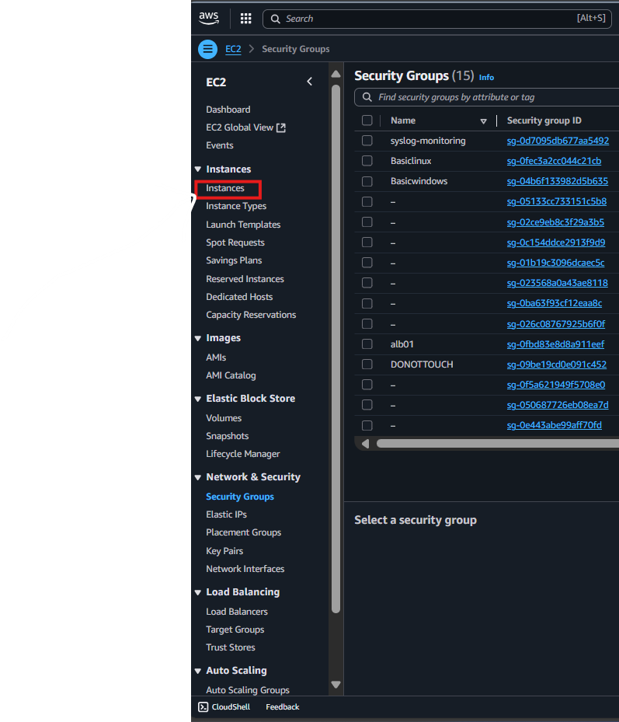
- Now select launch instance to begin provisioning your server
- 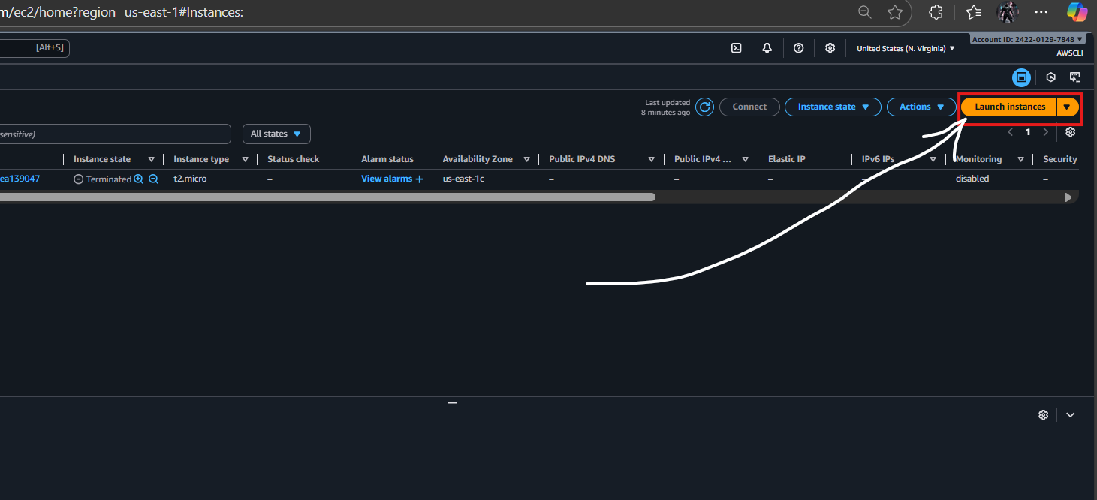
- Name instance: <class7hw1> Keep the rest default to keypairs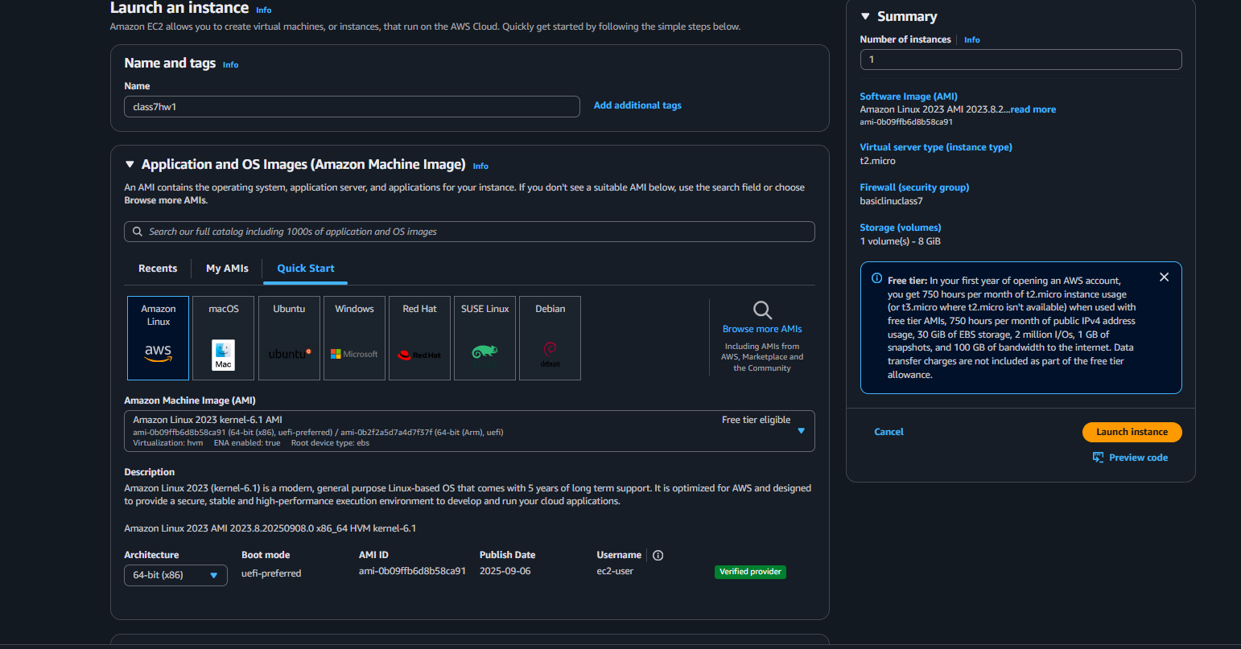
- Proceed without keypair for now, later we will provision these!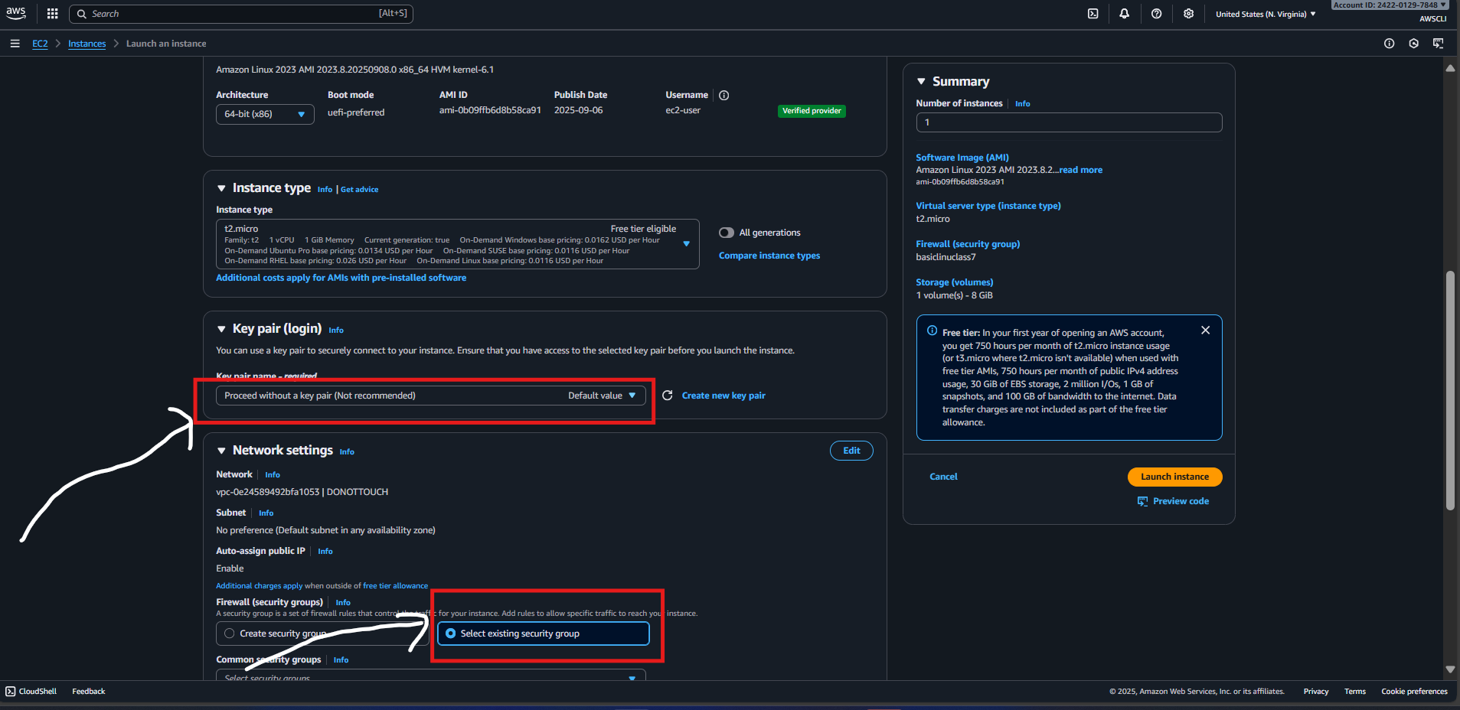
- Also select existing security group, choose security group you just made.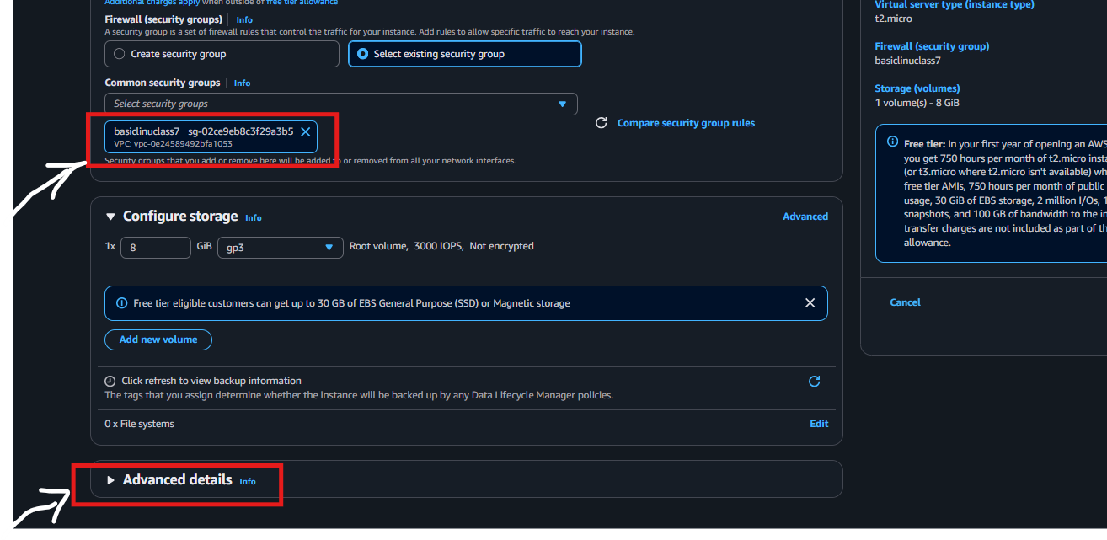
- After selecting Advanced details you go to the bottom of the menu.
- You have a script that is provided, copy raw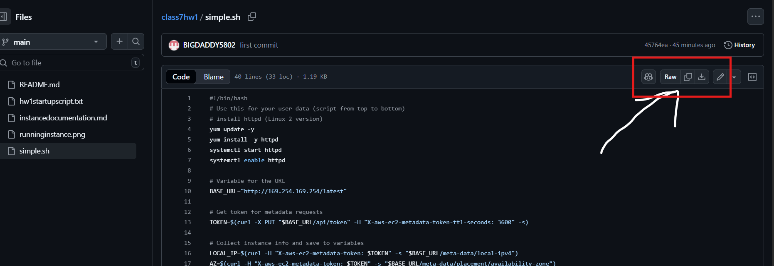
- class7hw1/simple.sh at main · BIGDADDY5802/class7hw1
- After copying raw go to the bottom of advanced details and paste in user data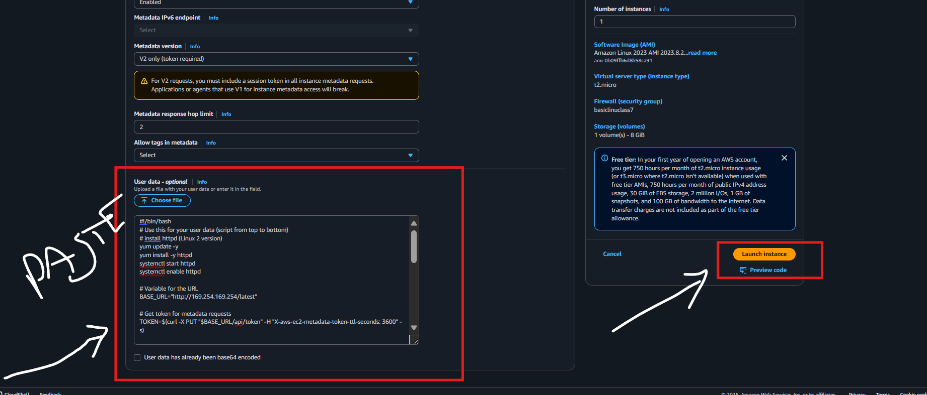
- After user data is pasted select launch instance.
- 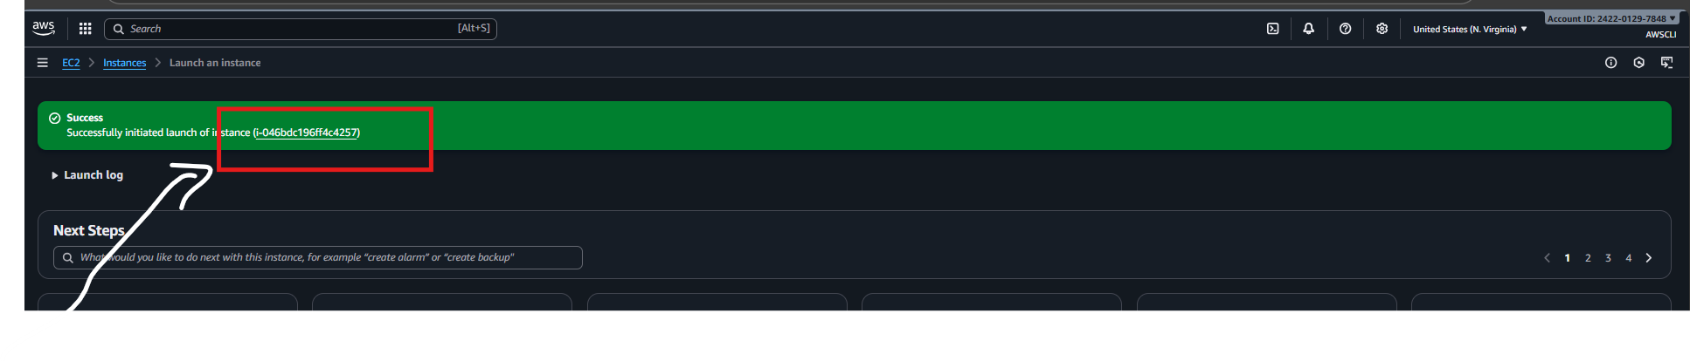
- Now to check if server is up and running click the hyperlink in the green success bar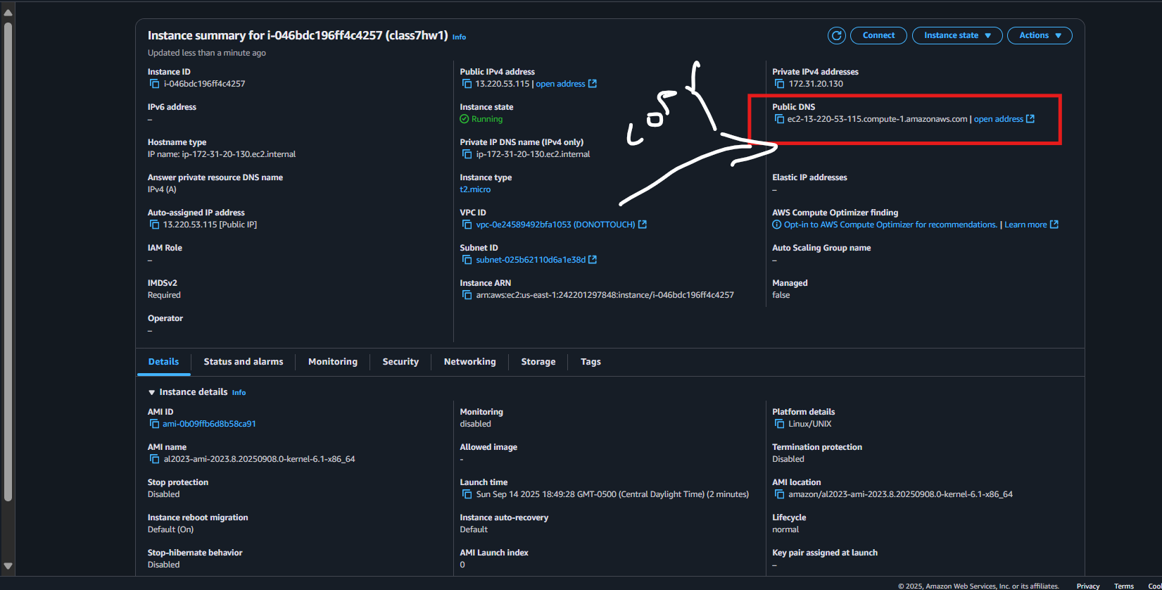
- After selecting hyperlink this is the screen you should see above ^
- Copy the public DNS, Select new tab, go to the address bar and type [http://]
- After typing http:// you then paste your Public DNS in the address bar
- Important: Ensure that is <http://> and not <https://>, This will stop you from accessing web page
- 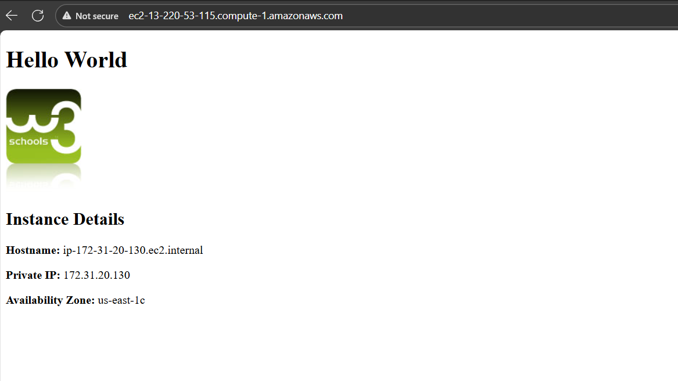
- This is what your webpage will look like. You have launched your server.

Teardown Instructions:
- Navigate to the instances screen
- Click the check box next to the running instance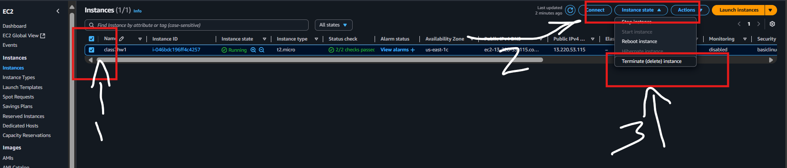
- Select instance state in top right > then select terminate instance in the dropdown menu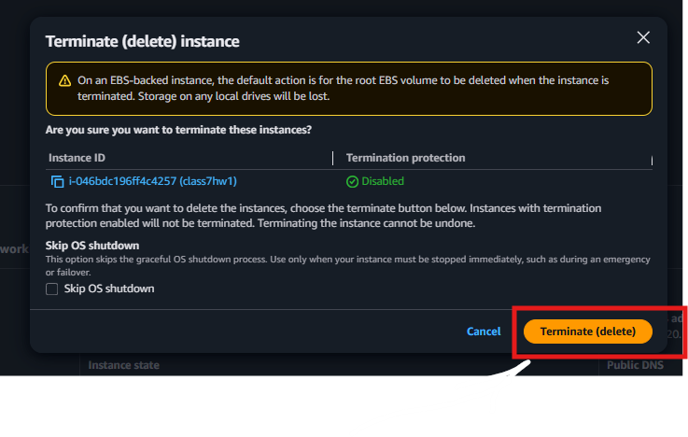
- In the new pop up screen select Terminate (Delete)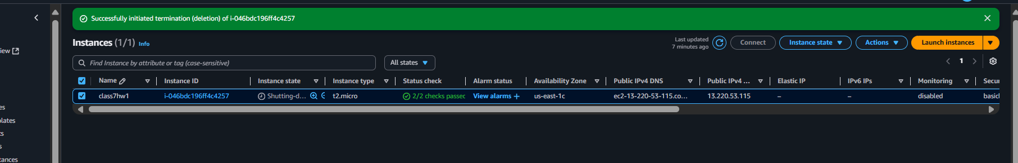
- The successful termination will be notated with a green bar that says successfully deleted and instance number
- You will see shutting down first by the instance, then it will be followed by terminated